  Vacation CAre  BREAK IV / 25/26  Dates: 15/12/25 – 22/01/26  Closed for Christmas Break: 22/12/25 – 03/01/26  Reopen: 05/01/26 – 23/01/26  VC Bookings Close on Friday 5th of December  (Return Booking Form, page 7, by Friday 05/12/25)  Details:  Open From 7am – 6pm  Monday – Friday  For Primary School Age Children  From All Schools  Contact:  Greenslopes State School, 559 Logan Rd, Greenslopes 4120; QLD  Ph: 3394 1609 M: 0409941609  Email: osca1@iinet.net.au  Website: www.oscacare.com | Incursions:  - Crazy Candles Spin Watch Art  - Magic Christmas Funday out  - Virtual Reality Athens  - Fun Time Water Wars  - Reverse Garbage  - TIE Diye  - Indigenous Event Emu Dreaming  - Urban Edu Bees Workshop  To Book  Book as a  CASUAL BOOKING  online through  Xplor Home App

Contents

FAMILY CHECKLIST …………………………………………………………………….3
GENERAL INFO 4
ONLINE BOOKING INSTRUCTIONS 6
HOLIDAY PROGRAM BOOKING FORMS ……………………………………7
VC PROGRAM ………………………………………………………………………..8

FAMILY CHECKLIST

- Return Booking Form, page 7, by Friday 1st December 2023
- Return Swimming Permission Form,
- If your child only attends vacation care, please check and if needed update your enrolment details
- Pack a healthy lunch (morning tea, lunch) – NO NUT PRODUCTS
(no nutbars)
- Ensure your child is wearing enclosed shoes (no thongs or sandals on excursions)
- Ensure your child has sun safe clothing, this includes:
- a shirt that covers shoulders (no singlets)
- a broad brimmed or legionnaire style hat (no caps or visors)
- if UV reading is under 3, children can play outside without a hat
- Label all personal items
- Bring a drink bottle
- Please leave electronics at home, they are no longer permitted at OSCA
- Talk to your children about the behaviour guidelines
- Junk / craft donations (boxes, wool, fabric etc.) are always welcome
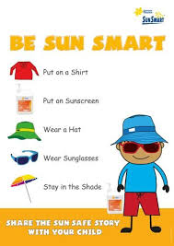


GENERAL INFO

Operated by Greenslopes SS P&C Association

Offers a broad range of activities for multi-age groups
QUALIFIED STAFF – 1:15
(Staff names, positions & qualifications on display at Parent’s desk)
AFTERNOON TEA – provided
CHILD CARE SUBSIDY – not paid prior to child physically commencing attending the service or after the child physically ceases attendance. These absences will be charged a full fee and will be excluded from our report to Centrelink.
FEES - $59.50 (permanent booking) & $64.70 (casual booking if booked after the vacation care started), plus excursions/incursions.
MONEY FOR EXCURSIONS/INCURSIONS - paid with the fees.
Families using the service on a casual basis will pay on the day of attendance.
Fees will be paid for all days booked as per DS agreement.
Accounts will be issued on Mondays.
SWIMMING FEES – FREE when swimming is on the program.
(Our swimming ratio is 1:5. Staff are rostered a week in advance to meet the ratio.)

ADMINISTRATION FEES - $15.00 paid annually only in one service VC/BA and on reenrollment at the beginning of each year.
CANCELLATION FEES: Full fees if less than one-week notice is given including swimming, plus activity/excursion. In the case of illness on presentation of medical certificate, no fees will be charged.
LATE FEES - $20.00 for the first fifteen minutes and then $2.00 for every minute after that (per child). At 6:30 pm, the emergency contact will be telephoned, and after that the Police or Department of Family and Community Service will be notified and the fee will be at the discretion of the Coordinator.
ADDITIONAL FEES - such as unsupplied lunch $10 and
$5.00 drink bottle/socks if needed at excursion only
PAYMENTS – Direct debit. Debit success only.

WHAT TO BRING TO OSCA’S VACATION CARE PROGRAM
FOOD – NUT FREE POLICY
IMPORTANT!!!!! CHILD/REN DIAGNOSED AT RISK OF ANAPHYLAXIS ARE ENROLLED AT THE SERVICE. PLEASE BE AWARE OF FOOD ALLERGIES OF CHILDREN ATTENDING OUR VACATION CARE. DO NOT INCLUDE FOOD CONTAINING NUTS IN YOUR CHILDREN’S LUNCH BOX.

YES – Healthy morning tea and lunch e.g. sandwiches, fruit, vegetables, water
NO - chips, Lollis, cakes, nutbars, peanuts or other nuts
NO GLASS CONTAINERS, RING PULL CANS
CHILDREN WITH SPECIAL FOOD REQUIREMENTS – Parents will provide food
STAFF CAN ONLY WARM UP COOKED FOOD (INCLUDING NOODLES) IN THE MICROWAVE

SUN SMART DRESS CODE
YES – wide brim hats, enclosed shoes, dresses or t-shirts with sleeves and bring their own sunscreen. Shorts must cover upper thighs. Suitable footwear.
NO – Baseball caps, singlet / sleeveless tops, no thongs or open-toed sandals
SWIMMING – Must be worn:
One-piece bathing suit, swimming shorts, sun-shirt/t-shirt, bathing cap,
Swim shirts during all water-based activities,
Hair must be secured in a bathing cap when swimming (boys and girls).

NOT TO BRING TO VACATION PROGRAM
OSCA takes no responsibility of toys and expensive items brought from home such as
ELECTRONIC DEVICES, MONEY, EXPENSIVE TOYS, JEWELRY, ALL VALUABLES.
ELECTRONIC DEVICES ARE NO LONGER PERMITTED. ONLY OSCA DEVICES WILL BE USED FOR SHORT 15’ TURN BEFORE LUNCH AND AFTERNOON TEA.
Students are encouraged to engage in other social learning and development activities. OSCA iPads will still be provided during designated technology time.
PLEASE NOTE THE FOLLOWING IN PARTICULAR:
- The Attendance Register must be signed upon arrival and departure
(Please advise a staff member of your arrival and departure)

VC ROUTINE
7.00- 9.00 Indoor games and play / outdoor games and sport.
9.00-9.30 Morning tea (Parents provide).
9.30-11.45 Planned activities – craft, sport and games.
11:45-12.15 Lunch (parents provide)
12.15-1pm Reading time/rest time for young children if they wish
12.30-1.30pm Swimming time (only during summer vacation care)
1pm-3pm Planned activities
3.00-3.30 Afternoon tea (OSCA provides)
3.30-5.30 Free play inside and outside.
5.30-6.00 All inside – Quiet play, wait for parents.
SUN SAFETY
Children playing outside must wear a hat.
- NO HAT> PLAY INSIDE or UNDERCOVER
- Only wide brimmed or legionnaire hats are acceptable.
- Children are required to bring their own sunscreen and will take responsibility for applying it when reminded by OSCA educators

ILLNESS / ACCIDENTS
In the event of an illness or injury to a child, a staff member will administer appropriate first aid. If medical assistance is required, parents will be contacted and if necessary the child will be accompanied by ambulance to the nearest hospital. The parents will meet all cost incurred in obtaining medical service.

MEDICATION Only medication prescribed and directed by the doctor will be administered in our centre. Parents need to present us with: A permission form, a letter from the doctor. A medication in original package with a pharmacist’s label stating the child’s name, dosage, frequency of administration, date of dispensing and expiry.

NOTIFICATION If a person other than those nominated on the enrolment form is to collect your child/ren, the service must be notified in writing. Authority to collect form with name, address and contact no must be completed. If the person is listed on enrolment form but was never met by staff on duty that day, that person will need to provide an ID with the photo on it.

GRIEVANCE PROCEDURE All parents’ concerns or complaints should be discussed with the coordinator. If parents are unsatisfied with the outcome, they may address their grievance in writing to the approved provider, P&C.

PARENT CODE OF CONDUCT
We would appreciate if parents DO NOT APPROACH TO CONFRONT CHILDREN other than their own, while they are under the care of Greenslopes OSCA. (Please see Parent Code of Conduct)

BEHAVIOUR – BIG 6 VALUES INTEGRITY, OPPORTUNITY, MUTUAL RESPECT, RESILIENCE, EMBRACING DIVERSITY, COMMUNITY
These values provide a framework for our service’s expectations of student behaviour to manage behaviour through a supportive model, which includes efficient supervision, provision of effective role models, directing or re-directing children to other activities and working with children to set out rules follow the rules and understand the consequences of breaking those rules. Any child displaying unacceptable behaviour persists, consultation may be necessary with parents, the child, coordinator and management committee. A child may be suspended from the program or excursions if unsatisfactory behaviour threatens the safety or wellbeing of any child or other person in the service. Please see Behaviour Management Policy for more details.

DAMAGE TO EQUIPMENT OR FACILITIES As part of everyday experiences involving children, we recognise that wear and tear wear occur. However, if damage is done that cannot be attributed to fair wear and tear but can be attributed to a malicious or intentional act on the part of a child, it will become an expense to the parent.

ONLINE BOOKING INSTRUCTIONS


Vacation care bookings are only accepted when booked online through Xplor Home app.

Please follow the link below for instructions and info on how to create bookings:
https://support.ourxplor.com/hc/en-us/articles/360037772111-Home-App-Creating-Bookings

FAMILIES NEW TO OSCA

Need to contact OSCA via email osca1@iinet.net.au to receive link to enrolment forms and make bookings. More information on how to create passwords and download Xplor Home app is at the link below:
https://support.ourxplor.com/hc/en-us/articles/900000777683-New-Parent-Guardian-Set-Up-

HOLIDAY PROGRAM REGISTRATION FORM – Break IV 2025/26 Week I, II, III & IV
CHILD’S GIVEN NAMES | CHILD’S SURNAME | PARENT/GUARDIAN | PARENT/GUARDIAN
Parents who enroll for the first time in Vacation Care must fill in full Enrolment Form
VC BOOKING
December | Week I | January | Week II | January | Week III | January | Week IV
Mon 15th | - Ornament Day | Mon 05th | - Travel to Athens VR  $20 Incursion | Mon 12th | - Reverse Garbage  $20 Incursion | Mon 19th | - Indigenous Event Emu Dreaming $10 Incursion
Tue 16th | - Crazy Candles Wall Clock Spin Art $20 Incursion | Tue 06th | - Seed Day | Tue 13th | - Taste of Italy | Tue 20th | - Rain Forest Day
Wed 17th | - Tinsel Day | Wed 07th | - Strawberry Day | Wed 14th | - Tie-Dye-Day  $10 Incursion | Wed 21st | - Urban Bees Hotel  $20 Incursion
Thu 18th | - Magic of Christmas  $10 Incursion | Thu 08th | - Ultimate Water War  $10 Incursion | Thu 15th | - Nature Day | Thu 22nd | - Underwater World
Fri 19th | - Jingle Bell Pizza Party  Free Pizza | Fri 09th | - Space Day | Fri 16th | - Superhero Day | Fri 23rd | - Movie Day
ACTIVITIES PERMISSION FORM VENUE – OSCA GREENSLOPES
Day | Date | Time | Cost | INCURSIONS | Activity
Tue | 16th December 25 | 09:30am | $20.00 | Crazy Candles Wall Clock Art | Children will make their own wall clock to take home with instructors.
Thu | 18th December 25 | 10:00am | $10.00 | Magic Christmas | Children will celebrate the Magic of Christmas
Fri | 19th December 23 | 12:00pm | FREE | Pizza lunch:  - Meat lovers  - Cheese | Optional:  Children will have Domino’s pizza for lunch
Mon | 05th January 26 | 09:30am | $20.00 | Travel to Athens VR | In this immersive VR adventure, children will explore Athens, Greek culture, and stunning city views as children were really there.
Thu | 08th January 26 | 9:30am | $10.00 | Ultimate Water Wars | Kids will race, dodge, soak, and laugh their way through fun water games designed for teamwork, excitement, and BIG summer fun. Perfect for staying cool and getting active!
Mon | 12th January 26 | 09:30am | $20.00 | Reverse Garbage | During our Reverse Garbage session, children will learn how everyday “rubbish” can be reused to create new and exciting thing.
Wed | 14th January 26 | 09:30am | $10.00 | Tie-Dye-Day | During Tie-Dye Day, children will explore colour, creativity, and hands-on art. Dye their own shirt.
Mon | 19th January 26 | 10:00am | $10.00 | Emu Dreaming | During our Emu Dreaming experience, children will explore Aboriginal culture, stories, and connection to Country
Wed | 21st January 26 | 10:00 am | $20.00 | Urban Bees Hotel | During our Urban Bee Hotel activity, children will discover how important bees are and how we can help them in the city
Reminder: enclosed shoes, sun safe hat, morning tea, lunch, a drink bottle, for younger children please pack spare clothes

By signing this form, I give permission to my child to participate in all activities provided as part of the Greenslopes SS OSCA Vacation Care Program including incursions & excursions. I acknowledge that all children attending on the day of an incursion/ excursion are required to participate in the activity.

I_______________________________________ hereby give permission for my child/ren to attend the activities organised by the Greenslopes SS Vacation Care program.
Parent’s Signature __________________________________ Date____________________

VACATION CARE PROGRAM December, January 2025/26 BREAK IV
All bookings and enquires please phone (07)33941609 or email: osca1@iinet.net.au or book easily online through Xplor app.
MONDAY 15/12/25 |  | TUESDAY 16/12/25 INCURSION | WEDNESDAY 17/12/25 | THURSDAY 18/12/25 INCURSION | FRIDAY 19/12/25
  ORNAMENT DAY  Let’s be creative and make our own beautiful Christmas ornaments!  Swimming app 12:30 – 1:30pm |  | 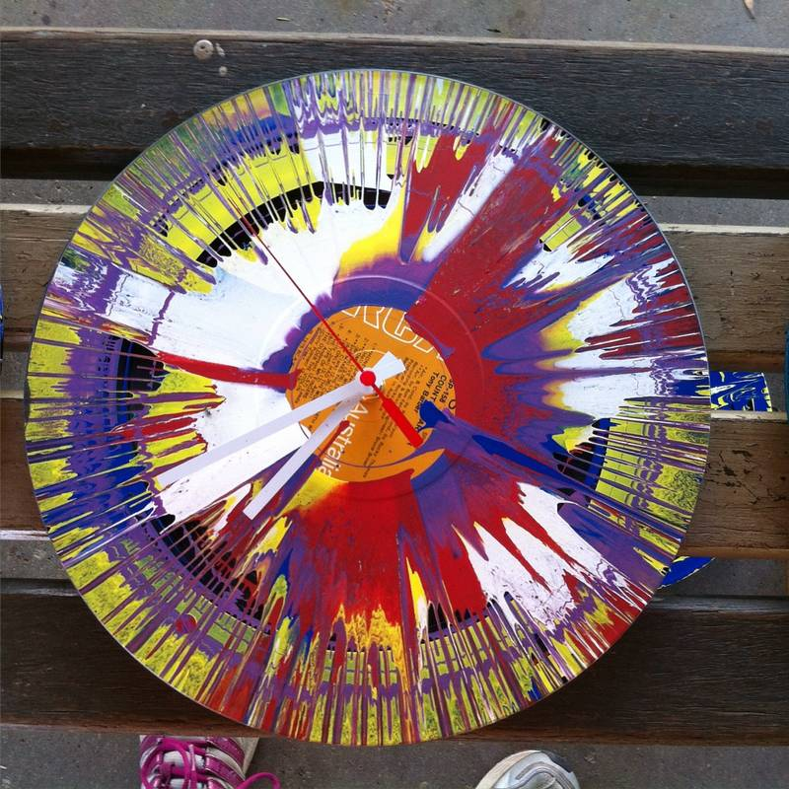  CRAZY CANDLES  SPIN ART  Spin, splash, and design! Turn vintage vinyl records into unique, colorful clocks using dynamic spin art.  Cost: $20 Time: 09:30am – 12:00pm |   TINSEL DAY  Get ready to sparkle, shine, and play! We can’t wait to celebrate with you!  Swimming app 12:30 – 1:30pm |   MAGIC OF CHRISTMAS  Children will become Santa’s magical elves to help Magic Pete and Santa bring the Christmas Magic alive!  Cost: $10 Time: 10am – 11:00am |   JINGLE BELL PIZZA PARTY  Spend our last day of the year enjoying Christmas themed music, art games, and movies.  Swimming app 12:30 – 1:30pm
Craft | Recycled CD Ornaments  Danish Christmas Heart | Christmas Paper plate wreath  Paper Plate Christmas baubles collage | Tinsel Garland Crowns or “Elf Hats  “Sparkly Christmas Cards with glitter glue and shiny paper | Paper Plate Rinder  Santa Masks or Beards using cotton balls | Jingle Bell Bracelets  Christmas crown or Paper Hat
Art | Salt and Dough Ornament  Nature ornament | Christmas tree dot painting | Spark Playdough in different colour | Christmas Art  Christmas Stencil bauble | Christmas Clay
Cooking/  Just for fun | Christmas tree out of paper bags and natural materials | Play Christmas Snow Fake | Cooking: Glitter Cookies | Decorate Gingerbread men house | Pizza lunch party  Christmas Karaoke Show
Sport & Games | Mini basketball  Elf Tag | Basketball  Kokan Indigenous Game | Handball  Tinsel Relay | Netball  Snowball Tag | Cricket  Musical Presents
 |  |  | SWIMMING EVERY DAY— INCURSION DAYS EXCLUDED
MONDAY 05/01/26 INCURSION |  | TUESDAY 06/01/26 | WEDNESDAY 07/01/26 | THURSDAY 08/01/26 INCURSION | FRIDAY 09/01/26
  TRAVEL TO ATHENS VIRTUAL REALITY  Explore the amazing Athen through a Virtual Reality headset.  Cost: $20 Time: 9:30-12:30pm |  | 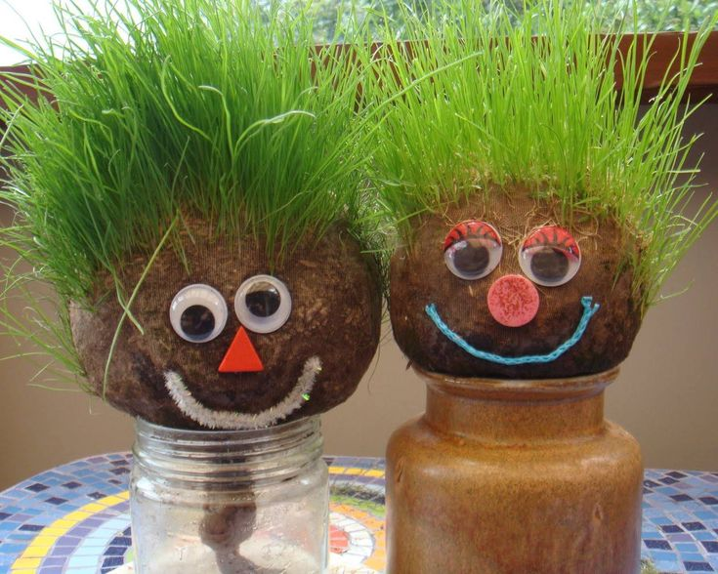  SEED DAY  Come join us for a fun and exciting Seed Day Activity where we’ll learn, play, and grow together!  Swimming: 12:30 – 1:30pm |   STRAWBERRY DAY  0It’s a wonderful day to enjoy some strawberries and have lots of fun!  Swimming: 12:30 – 1:30pm | 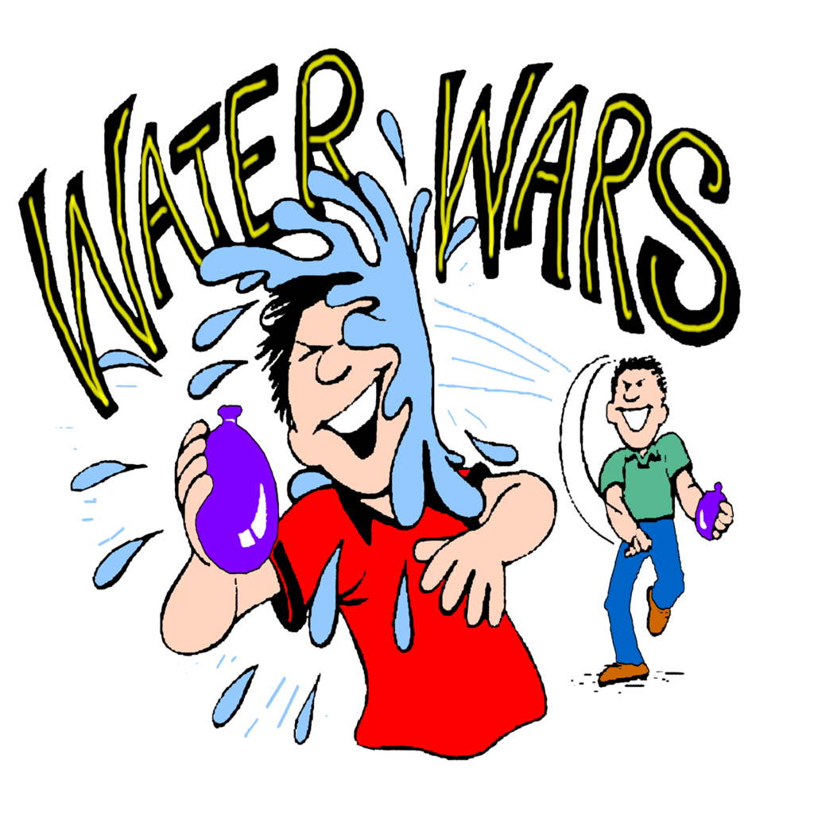  ULTIMATE WATER WARS  Bring spare clothes for a fun filed water play day. Get ready for Ultimate Water Wars!  Cost: $10 Time: 9:30-12:30pm |   SPACE DAY  Join us as we explore the stars, planets, and galaxies on our special Space Day!  Swimming: 12:30 – 1:30pm
Craft | Greek Mythology Mask  Olive paper leaf crown | Make your own paper cup for seed growing | Strawberry paper craft 3D  Strawberry Headbands | Floating Boat Craft  Rain stick Craft | Make your own planet or rocket craft  Alien Masks
Art | Greek Mosaic Art | Indigenous Seed Art | Strawberry Playdough | Bubble prints  Ice cube painting | Making galaxy slime  Galaxy Painting
Cooking/  Just for fun | Build the Parthenon  Greek Sand Art | Growing chia cress  Weighing seeds Tray | Cooking: Making strawberry Ice Cream | Fun: Water plays fun incursion | Rocket or Spaceship out of cardboard group project
Sport & Games | Tennis  Snakes and Ladders | Master Ball  Poison Letter | Badminton  Fruit memory snap cards | Dodgeball  Egg and Spoon Race | Volleyball  Twister
Spontaneous play is encouraged, and children are supplied with resources to support their imagination. A variety of indoor and outdoor equipment are set up daily.
RISK ASSESSMENTS OF VC ACTIVITIES ARE AVAILABLE FROM OSCA OFFICE/PARENTS TABLET
PLEASE PACK FOR YOUR CHILD: MORNING TEA AND LUNCH, WATER BOTTLE, SUN SAFE HAT, ENCLOSED SHOES, SPARE CLOTHES. PLEASE PACK SWIMMING TOGS IF YOUR CHILD WILL BE SWIMMING. PLEASE LEAVE TECHNOLOGY DEVICES AND VALUABLES AT HOME.

VACATION CARE PROGRAM BREAK IV January 2026 WEEK 3 & 4
All bookings and enquires please phone (07)33941609 or email: osca1@iinet.net.au or book easily online through Xplor app.
MONDAY 12/01/26 INCURSION |  | TUESDAY 13/01/26 | WEDNESDAY 14/01/26 INCURSION | THURSDAY 15/01/26 | FRIDAY 16/01/26
REVERSE GARBAGE  Lt’s enjoy make your own creation out of recycling materials.  Cost: $20 Time: 9:30-11:45pm |  |   TASTE OF ITALY  Come and enjoy a taste of Italy with us! We’ll be making and tasting yummy Italian pasta.  Swimming: 12:30 – 1:30pm |   TIE DIYE DAY  Get creative and time dye your own T-shirt in fun colours. Please bring your spare shirt or socks for Tie Diye.  Cost: $10 Time: 9:30-11:45pm | 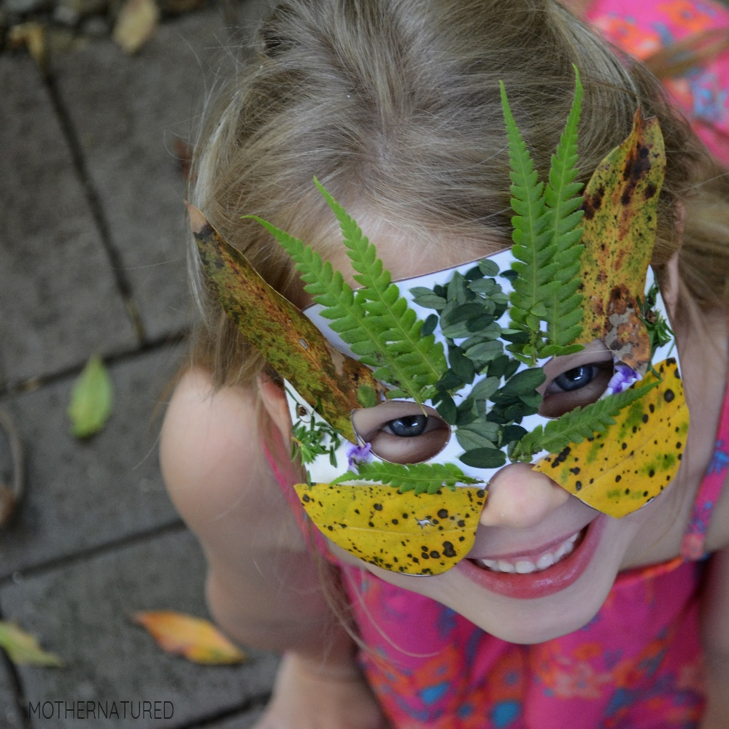  NATURE DAY  Join us for a fun-filled Nature Day at OSCA — a day packed with crafts, art, and outdoor adventures!  Swimming app 12:30 – 1:30pm | SUPERHERO DAY  Today is superheroes day. Come dressed as your favourite superhero. We will watch Incredibles -Play some super games.  Swimming: 12:30 – 1:30pm
Craft | Craft Stick Catapults | Make your own pasta necklace  Italian flag | Making kite | Leaf’s confetti  Nature Suncatchers | Making superhero mask  Superhero Capes
Art | Paint Your Plaster Creations | Italian Mosaic Art | Decorate your own kite  Coffee Filter Tie-Dye Butterflies | Rock paintings  Painting on Bark | OSCA Superhero Mural  Create Your Own Superhero Portrait
Cooking/  Just for fun | Plaster Sculptures | Cooking Italian Pasta | Tie dying your own shirt | Scavenger Hunt | Superhero Obstacle Course
Sport & Games | Hockey  Mini Golf | Table Tennis  Belt Tag | Soccer  Playground | Tennis  Wan Indigenous game | AFL  Rescue Mission Game
 |  |  | SWIMMING EVERY DAY— INCURSION DAYS EXCLUDED
MONDAY 19/01/26 INCURSION |  | TUESDAY 20/01/26 | WEDNESDAY 21/01/26 INCURSION | THURSDAY 22/01/26 | FRIDAY 23/01/26
  OUR COUNTRY, OUR LAND  A cultural activity day that celebrates Aboriginal and Torres Strait Islander traditions through storytelling.  Cost: $10 Time: 10am-11:00am |  |   RAINFOREST DAY  Get ready to explore the wild and wonderful world of the rainforest!  Swimming app 12:30 – 1:30pm | 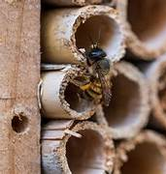  URBAN BEES HOTEL Learn about the amazing world of pollinators - Honey Bees! Build your own hybrid solitary bee hotels.  Cost: $20 Time: 10am-12:00pm |   UNDERWATER WORLD  Cool off with some water games and get inspired by the ocean.  Swimming app 12:30 – 1:30pm |   MOVIE DAY We will watch an awesome movie, enjoy yummy snacks, and take part in fun crafts and activities inspired by your favourite films! Swimming app 12:30 – 1:30pm
Craft | Animal Spirit Mask  Making Boomerangs | Rainforest animal masks  Making Binoculars | Paper Plate Bees  3D Bee Puppets | Paper plate Aquarium  Jellyfish Lanterns | Making movie tickets  Make a Photo booth out of cardboard
Art | Story Stones | Textured leaf rubbings | Honeycomb Art, Beach Shell Bees | Plaster Sea Creations | Create a movie poster
Cooking/  Just for fun | Indigenous Musical Instruments | Tropical fruit cups with custard | Honeybee Sensory Try | Water plays sensory try and make ocean water bottles | Popcorn and movie time
Sport & Games | Badminton  Indigenous Games | Dodge Ball  Parachute game | Tennis  Waggle Bees Dance | Hoola Hoops game  Shark and Fish Tag | Netball  Circle Dodge Ball
Spontaneous play is encouraged, and children are supplied with resources to support their imagination. A variety of indoor and outdoor equipment are set up daily.
RISK ASSESSMENTS OF VC ACTIVITIES ARE AVAILABLE FROM OSCA OFFICE/PARENTS TABLET
PLEASE PACK FOR YOUR CHILD: MORNING TEA AND LUNCH, WATER BOTTLE, SUN SAFE HAT, ENCLOSED SHOES, SPARE CLOTHES. PLEASE PACK SWIMMING TOGS IF YOUR CHILD WILL BE SWIMMING. PLEASE LEAVE TECHNOLOGY DEVICES AND VALUABLES AT HOME.

