HOLIDAY PROGRAM REGISTRATION FORM – Break II 2026 Week I & II
CHILD’S GIVEN NAMES | CHILD’S SURNAME | PARENT/GUARDIAN | PARENT/GUARDIAN
Parents who enroll for the first time in Vacation Care must fill in full Enrolment Form

VC BOOKING
June/July | Week I 29/06/26 - 03/07/26 | July | Week II 06/07/26 - 10/07/26
- Mon 29th  June | Yarn Day | - Mon 6th | Old MacDonalds Travelling Farm  $15.00 Incursion
- Tue 30th | Kite Fun Day  $15.00 Incursion | - Tue 7th | Zone Bowling Excursion  $20.00 Excursion
- Wed 01st | Wizard Workshop  $20.00 Incursion | - Wed 8th | Celebrating Naidoc Week VR Incursion  $20.00 Incursion
- Thu 02nd | Pokémon Day | - Thu 9th | Show and Share Your Culture
- Fri 03rd | Winter Wonderland | - Fri 10th | Hot Chocolate & Pj’s Day

ACTIVITIES PERMISSION FORM VENUE – OSCA GREENSLOPES
Day | Date | Time | Cost | INCURSIONS | Activity
Tue | 30th June 26 | 09:30am | $15.00 | Kite Fun Day | Children will make and decorate their own kite to keep.
Wed | 1st July 26 | 10:00am | $20.00 | Wizard Workshop | Children will Build confidence while learning new skills in a fun, engaging, and magical environment.
Mon | 6th July 26 | 10:00am | $15 | Old MacDonalds Travelling Farm | Children will learn about a variety of farm animals, their characteristics, and how to care for them safely and responsibly
Tue | 7th July 25 | 09:00am | $20.00 | Zone Bowling Excursion | Children will enjoy a fun and active experience that promotes physical activity, social interaction, and positive recreation.
Wed | 8th July 26 | 10:00am | $20.00 | Celebrating Naidoc Week VR Incursion | Through storytelling Time kids will explore Indigenous culture. Understand more about connection to Country, respect for nature, and community values.
Reminder: enclosed shoes, sun safe hat, morning tea, lunch, a drink bottle, for younger children please pack spare clothes

By signing this form, I give permission to my child to participate in all activities provided as part of the Greenslopes SS OSCA Vacation Care Program including incursions & excursions. I acknowledge that all children attending on the day of an incursion/ excursion are required to participate in the activity.

If your child is attending any excursions, an excursion permission form must also be completed (see below).
Any medical details we should be aware of? Please note: If your child requires medication to be administered at OSCA a medication administration form must be completed daily upon arrival. All medication must be in original packaging with child’s name.

I_______________________________________ hereby give permission for my child/ren to attend the activities organised by the Greenslopes SS Vacation Care program.

Parent’s Signature __________________________________ Date_____________________


EXCURSION PERMISSION FORM
WEEK II – EXCURSION RISK ASSESSMENTS OF VC ACTIVITIES IS AVAILABLE FROM OSCA OFFICE
DAY: Tuesday | DATE: 07/07/2026 | EXCURSION - ZONE BOWLING
DAY: Tuesday | DATE: 07/07/2026 | VENUE - 533 KESSELS RD,  MACGREGOR QLD 4109
COST: $ 20.00  (includes 2 games, bus, additional staff & lunch)  ADDITIONAL COST OF $5- if child forgets socks  SOCKS & ENCLOSED SHOES MUST BE WORN! |  | Activity:  2 games of bowling  Lunch: (Please tick the option you would like for your child.)  - CHICKEN NUGGETS, FRIES & DRINK  - MARGARITA PIZZA  - VEGAN  Please note we are not able to offer alternative food for your child
  **Please note**
  The P & C Association are proudly subsiding this excursion only, to be able to reintroduce excursions to Vacation Care. We are looking forward to having future Vacation Cares with one excursion per week
TIME: 9:00am – 1:30 pm app.
TRAVEL: Mt. Gravatt Coach & Travel
(the bus is fitted with seat belts)
DEPARTING OSCA - 9:00AM SHARP.
RETURN to OSCA - 1:30PM approximately.
All travelling times are approximately
20 minutes in each direction.
CHILD EDUCATOR RATIO: 1-8 & 1 non-contact
DOCUMENTS DISPLAYED ON PARENT’S NOTICE BOARD & OSCA ENTRANCE DOOR
- NOMINATED SUPERVISOR/ SUPERVISOR IN CHARGE
- Approx. number of children attending excursion
- Numbers and names of the educators attending the
excursion
- Educators with First Aid certificate attending the excursion
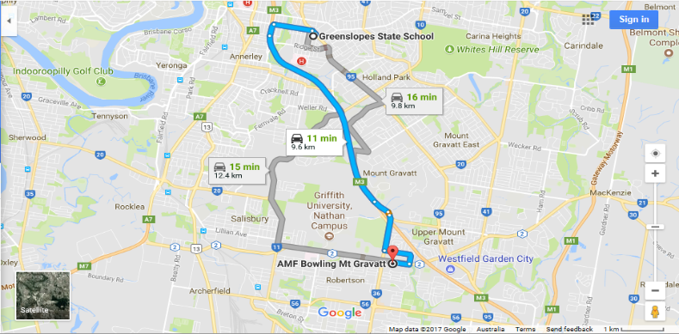
TRAVEL MAP:
from GSS OSCA to AMF Bowling M. Gravatt & Return to GSS OSCA

**The risk assessment has been completed and is available at OSCA**
I________________________________________ hereby give permission for my child/ren______________________________________________________________________________
to attend the above activity organised by the Greenslopes State School Vacation Care program for the
Break II 07/07/26.

Signature Date

MONDAY 29/06/26 |  | TUESDAY 30/06/26 INCURSION | WEDNESDAY 01/07/26 INCURSION | THURSDAY 02/07/26 | FRIDAY 03/07/26
  YARN DAY Get ready to twist, wrap, and create! Join us for a super fun day of easy yarn crafts and awesome art projects. |  |   KITE FUN DAY  Make and fly your very own kites.  Cost: $15 Time: 09:30 – 12:00pm |   WIZARDING WORKSHOP  Become a movie star with oosh TV’s green screen & visual effects.  Cost: $20 Time: 10:00 – 12:00pm | 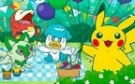  POKÉMON DAY ADVENTURE  Calling all Pokémon trainers! Get ready to explore at our exciting Pokémon day. |   WINTER WONDERLAND Welcome the chilly season with frosty  winter-themed craft and art activities
Craft | Yarn monsters  Make a Manu Tukatuku out of Yarn | Kite craft  Paper helicopters | Paper Plate and paper roll Wizard Craft  Making Masks | Pikachu Chatterbox  Poke ball Suncatcher Art on CD | Paddle pop stick snowmen Paper snowflakes
Art | Painting with yarn without paint | Wet chalk drawing  Tile decorating | Wizard Wand -painting on wooden stick and face painting | Draw your favourite Pokémon | Salt snowflake painting  Winter scene art
Cooking/  Just for fun | French knitting | Kite flying | Wizarding Workshop Incursion | Make Pokémon badges DIY Poke ball | Fake snow, sensory play
Sport & Games | Netball  String Maze game | Badminton  Parachute Game | Lacrosse  Belt Tag | Volleyball  Capture the flag | Hockey Dodge ball
MONDAY 06/07/26 INCURSION |  | TUESDAY 07/07/26 EXCURSION | WEDNESDAY 08/07/26 INCURSION | THURSDAY 09/07/26 | FRIDAY 10/07/26
  OLD MACDONALD’S TRAVELLING FARM  Old MacDonald’s farm is coming to OSCA! Enjoy gently patting and feeding baby animals in a mobile petting zoo. Cost: $15 Time: 10:00am – 1:00pm |  |   ZONE BOWLING EXCURSION MT GRAVATT Including 2 games and lunch  9:00am-1:30pm Cost: $20 |   CELEBRATE  NAIDOC WEEK Celebrate and learn about Aboriginal and Torres Strait Islander cultures as NAIDOC week begins.  Cost: $20 Time: 10:00 – 12:00pm |   SHOW AND SHARE YOUR CULTURE Let’s take pride in the cultural diversity within OSCA. Bring photos, objects, or costumes to share your culture with us! |   HOT CHOCOLATE & PJS DAY  Come dressed in your PJs and enjoy a warm chocolate drink.
Craft | Making animal masks | Children’s choice | Boomerang craft  Natural materials wall hangings | Multi Skin Tone Paper Faces & Paper People | Paper cup hot chocolate craft
Art | Native animals from clay | Making ochre | NAIDOC mural art | Drawing Folk Costumes  Dot Painting | Make chocolate playdough  Foil painting
Cooking/  Just for fun | Bird watching Play Indigenous Musical Instruments | Babble Blowing | Cooking: Damper VR Pamagirri Community Exploring | Making chocolate waffles (oblanda) | Cooking: Warm drinking chocolate Play dramatic game-chocolate shop
Sport & Games | Tennis Run, Rabbit, Run | Basketball  Grab the nest | Long Jump  Buroinjin Indigenous game | Dancing to Music from Different Cultures  Children’s Choice of Games | AFL Musical Squares, Indigenous Games
Spontaneous play is encouraged, and children are supplied with resources to support their imagination. A variety of indoor and outdoor equipment are set up daily.
RISK ASSESSMENTS OF VC ACTIVITIES ARE AVAILABLE FROM OSCA OFFICE/PARENTS TABLET
PLEASE PACK FOR YOUR CHILD: MORNING TEA AND LUNCH, WATER BOTTLE, SUN SAFE HAT, ENCLOSED SHOES, SPARE CLOTHES. PLEASE LEAVE TECHNOLOGY DEVICES AT HOME.
VACATION CARE PROGRAM BREAK 2 / 26 June / July WEEK 1 & 2
All bookings and enquiries please phone (07) 3394 1609 or email: oscagreenslopes@gmail.com or book easily online through Xplor app.

